**Integrate Jenkins with Selenium And Github**

**Steps 1:** Download Jenkins.war file from : <https://www.jenkins.io/download/>

**Steps 2:** Download - Generic java package (.war)

**Steps3:** On Command line:

**Steps4:** Go to folder where Jenkins is installed

**Steps5:** Open on browser: <http://localhost:8080/>

**Steps6:** Try 9090 if port 8080 is already in use.

**Steps7:** From cmd enter initialAdminPassword.

**Steps8:** Click on continue button.

**Step9:** Now choose “Install Suggested Plugins”.

**Step10:** After plugin installation we have to create new admin account. Type in your admin username and password, email,etc, and Click on “Save and Finish”.

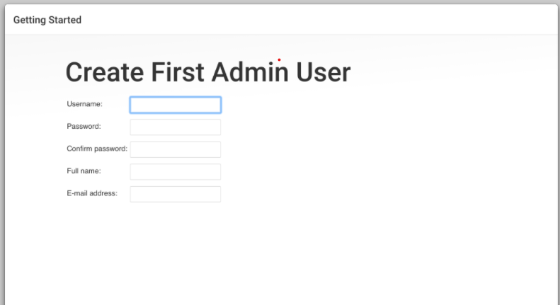

**Step11:** Configuration completed and Jenkins is ready and you can start working with it after “click start using Jenkins” button.

**Step12:** Now you will be redirected to Jenkins dashboard and show the default Jenkins screen. Jenkins installation and Configuration finished successfully.

**Step13:** Now click on Manage Jenkins and In system configurations click on Manage Plugins

**Step14:** Click on Available and search Required Plugins.

**Step15:** Click on “Download now and install after restart”.

**Step16:** Now go to Dashboard and click on “New Item”.

**Step17:** Now enter some name then select maven project an d click on ok button.

